**Heat and Temperature**

**Pre-lab questions**

1. What is the goal of this experiment? What physics and general science concepts does this activity demonstrate to the student?
2. What is the physical meaning of temperature?
3. Should identical amounts of heat change the temperature of differing amounts of water by the same amount?

The goal of this experiment is to study the relationship between heat (internal energy) and temperature.

Introduction

**Heat**, or **thermal energy**, is defined as the internal kinetic energy of the random motion of atoms and molecules in a substance (solid, liquid, or gas). Thermal energy exists when the atoms and molecules in an object are all moving randomly with respect to each other so that there is no net motion of the object. It is distinguished from the kinetic energy we already know about, where most of the atoms and molecules making up an object share an average velocity in a particular direction. The thermal energy in an object is a representation of the total kinetic energy from the random motion of all the particles that make up the object.

**Temperature** is a physical measurement of how "hot" or "cold" a substance is based on the average kinetic energy of random motion of particles in the substance, it is a measure of the average kinetic energy per particle. Not all particles in the substance need to start out with the same average kinetic energy. “Hotter” particles may have higher kinetic energy and “colder” particles lower. But if the substance is left alone for a while, collisions between the particles in the substance will tend to even things out. A collision between a hotter particle and a colder one will, on average, tend to transfer some kinetic energy from the hot particle to the cold one. Eventually, all the particles in the substance will have about the same average kinetic energy. This situation is called **thermal equilibrium**. Even though particles of different types may have very different masses, their respective velocities will have compensating average differences such that the average kinetic energy of the particles are very close.

Heat can be transferred between two or more objects by way of thermal interaction (conduction, radiation, or convection). Heat, like mass or volume, is an **extensive** quantity, it depends on how much there is to the object. Similar to mechanical energy, heat energy is a conserved quantity. On the other hand, temperature is an **intensive** quantity. In that regard, it is similar to density (mass per unit volume) or pressure (force per unit area).

The amount of heat energy in an object is related to temperature, but temperature by itself cannot tell you how much thermal energy (heat) is in an object. Identical thermometers in two pots of water on a hot stove will show different temperatures even if the pots have been on the stove for the same time, if the amount of water in one pot is different than the amount in the other.

Equipment

Wireless temperature sensor, energy transfer calorimeter, 100 ml graduated cylinder, water

Experiment

The purpose of this activity is to explore the relationship between heat and temperature by measuring the amount of temperature change in two different volumes of the same fluid, subject to the same amount of added thermal energy.

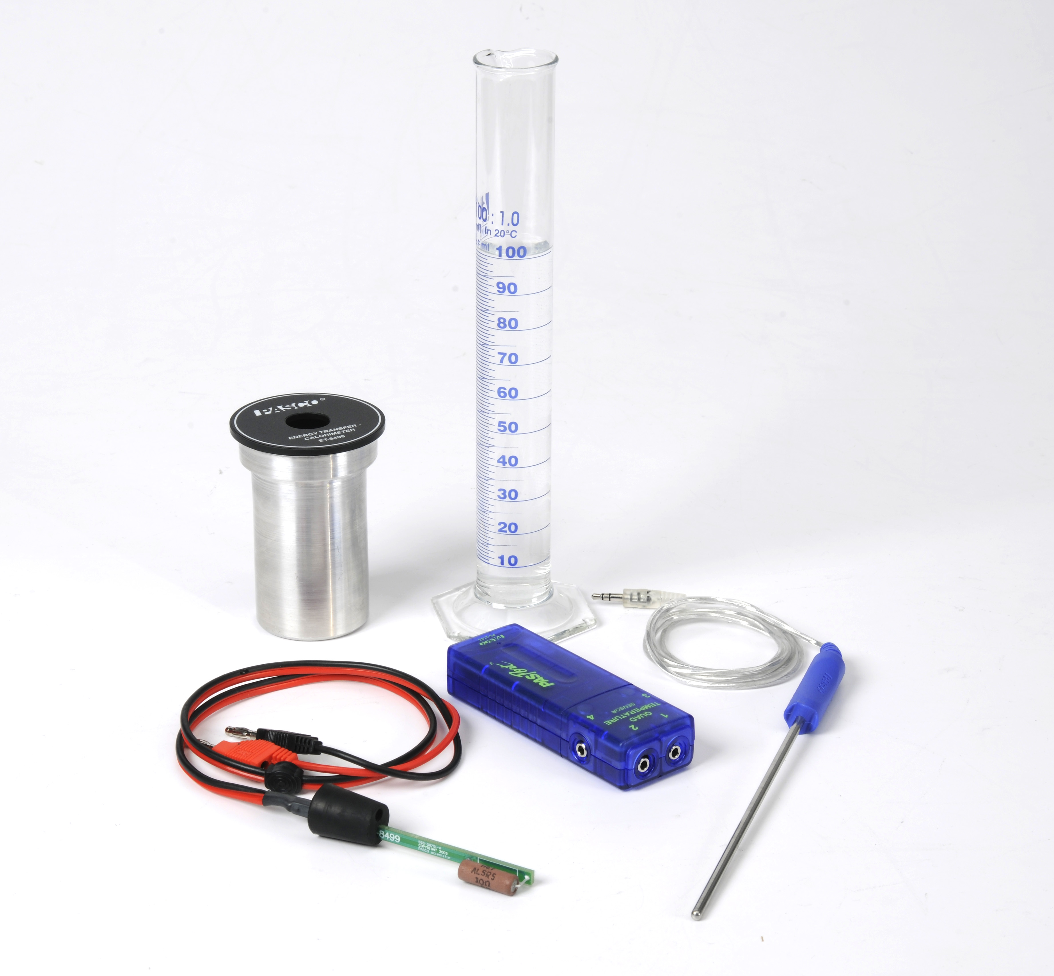

Figure 1: Apparatus

Setup

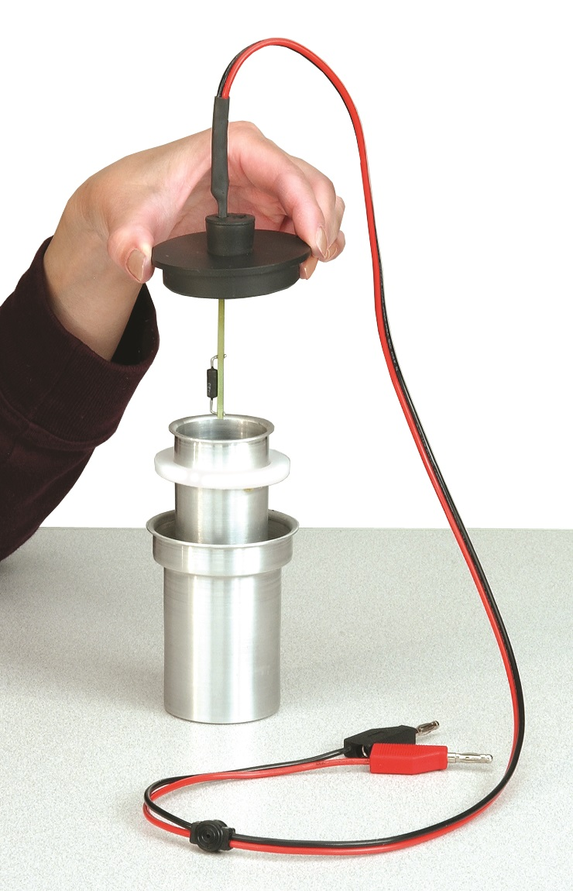

Figure 2: Calorimeter Assembly

1. Assemble the Energy Transfer Calorimeter similar to Figure 2, using the heating resistor with two-hole rubber stopper.
2. Connect the red and black patch cords from the heating resistor to Output #1 on the 850 interface.
3. Connect the Wireless Temperature sensor to any PASPORT channel on the 850 interface, and then connect a stainless steel temperature probe to the Wireless Temperature sensor.
4. Insert the stainless steel temperature probe into the second hole on the two-hole rubber stopper and gently push the probe down until it touches the bottom of the calorimeter cup.
5. In PASCO Capstone, set the sample rate to 1 Hz.

Figure 2: Calorimeter Assembly

1. Create a graph of Temperature vs. Time.

**→**Resistor Safety**←**

Data will be collected on the next pages, and during data collection about 1 A of current will be continuously flowing through the resistor. This current will cause the resistor to heat up which will in turn heat the water that will be placed in the calorimeter. Do not start recording data until the heating resistor is completely submerged in the water. Collecting data while the resistor is not submerged can cause it to burn up, or be dangerously hot. Do not touch the heating resistor.

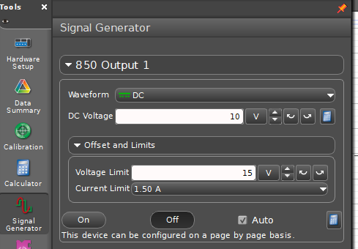To set the proper current for the 10 Ω resistor, open the Signal Generator and set the output voltage to 10 V with DC waveform, and set the voltage limit to 15 V.

Procedure: 40 ml

1. Use the graduated cylinder to measure 40 ml of water, and then lift the lid on the calorimeter and pour the measured water into the inner cup.

NOTE: Use cool (not cold) tap water, or water that has an initial temperature below 24°C.

1. 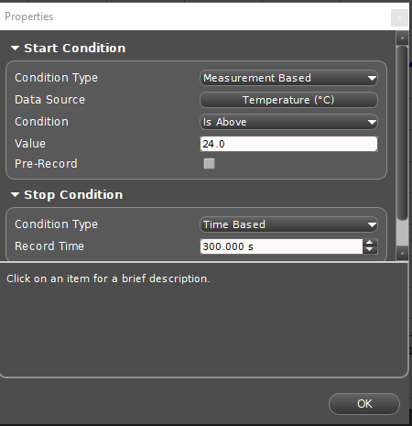Replace the calorimeter lid with the heating resistor and stainless steel temperature probe submerged in the water in the cup.
2. Set start/stop conditions by clicking on recording conditions and setting the Start condition as Measurement Based, Temperature, °C, and Above 24.0. Set a Stop condition as Time Based at 300.000 s.
3. Click the record button below to activate the heating resistor. Data will not be recorded until the temperature of the water in the calorimeter reaches 24°C, and then will automatically stop after 300 seconds (5 minutes).
4. Gently swirl the water in the cup as data is recorded so the water will be heated evenly.
5. When data recording stops, pour out the warm water and set the calorimeter lid with temperature probe and heating resistor on the lab table for about a minute to cool.

Procedure: 60 ml

1. Use the graduated cylinder to measure 60 ml of water, and then pour the measured water into the inner cup in the calorimeter.

NOTE: Use cool (not cold) tap water, or water that has an initial temperature below 24°C.

1. Replace the calorimeter lid with the heating resistor and stainless steel temperature probe submerged in the water in the cup.
2. Click the record button below to activate the heating resistor. Data will not be recorded until the temperature of the water in the calorimeter reaches 24°C, and then will automatically stop after 300 seconds (5 minutes).
3. Gently swirl the water in the cup as data is recorded so the water will be heated evenly.

Analysis

1. Use the graph tools to determine the change in temperature for each volume of water, 40 ml and 60 ml. Record both values below.
2. How does the temperature change, ΔT, for 40 ml of water compare to the ΔT for 60 ml of water?
3. Did the 40 ml of water receive more, less, or the same amount of energy as the 60 ml? Why?
4. Considering your answer to the previous question, why is the final temperature of the 40 ml of water higher than the 60 ml.